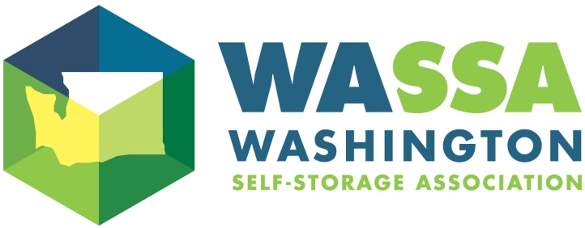
2023 Annual Trade Show
Friday, May 19, 2023
Hilton Seattle Airport & Conference Center
17620 International Blvd, Seattle, WA 98188

Vendor Registration
VENDOR INFORMATION

Company Name: ___________________________________________________________________________________________________________________________

Address: ____________________________________________________________________________________________________________________________________

City/State/Zip _____________________________________________________________________________________________________________________________

Contact name___________________________________________________ Contact email & phone__________________________________________________

Platinum Sponsorship includes up to three attendees; Gold & Silver Sponsorship includes up to two attendees.
Additional representatives and/or guests are welcome and may be registered at the member rate.
Submit name, email and cell phone for each attendee. Use reverse side if necessary

First attendee _________________________________________________ Email & Cell ____________________________________________________________

Second attendee ______________________________________________ Email & Cell ____________________________________________________________

Sponsorship Levels:

Platinum Sponsor – limit 8 at this level. (up to 3 representatives/attendees)
Includes choice foyer booth location if desired, company logo included in PowerPoint presentation
displayed throughout the day; optional insert in day-of handouts. Platinum registrants are exclusive
sponsors of the Cocktail Reception at end of conference day
Member Vendor $2,300.00
Non-Member Vendor $2,800.00

Gold Sponsor – limit 10 at this level (up to 2 representatives/attendees)
Includes choice foyer booth location if desired (based on availability); company logo included
in PowerPoint presentation displayed throughout the day and optional insert in day-of handouts
Member Vendor $1,900.00
Non-Member Vendor $2,400.00

Silver Sponsor – limit 20 at this level (up to 2 representatives/attendees)
Includes booth at annual trade show and optional insert in day-of handouts
Member Vendor $1,500.00
Non-Member Vendor $2,000.00

Send a CURRENT logo for placement on our website. Also to be used with the PowerPoint and included on posters at the event displaying you as a 2023 WA-SSA Conference Sponsor. These should be sent immediately to info@wa-ssa.org. All sponsors are listed in the “Day of Event” handout and mentioned at breaks. We must have handout materials no later than May 5, 2023.

Register online: www.wa-ssa.org or mail in form with check to the address below

Washington Self Storage Association (WA-SSA) 1402 Lake Tapps Pkwy SE, Ste. F104/PMB 133; Auburn, WA 98092

Email info@wa-ssa.org Questions, call WA-SSA at 206-653-7259 or visit our website, www.wa-ssa.org.

