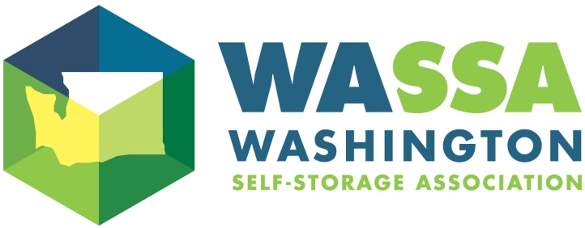
2022 Annual Trade Show
Friday, May 20, 2022
Hilton Seattle Airport & Conference Center
17620 International Blvd, Seattle, WA 98188

Vendor Registration
VENDOR INFORMATION

Company Name: ___________________________________________________________________________________________________________________________

Address: ____________________________________________________________________________________________________________________________________

City/State/Zip _____________________________________________________________________________________________________________________________

Contact name___________________________________________________ Contact email & phone__________________________________________________

Platinum Sponsors can have up to three attendees; Gold & Silver Sponsors receive up to two representative attendees.
Additional representatives and/or guests are welcome and may be registered at the member rate.
Submit name, email and cell phone for each attendee. Use reverse side if necessary

First attendee _________________________________________________ Email & Cell ____________________________________________________________

Second attendee ______________________________________________ Email & Cell ____________________________________________________________

Sponsorship Levels:

Platinum Sponsor – limit 10 at this level. (up to 3 representatives/attendees)
Includes choice foyer booth location if desired; inclusion in PowerPoint presentation
Shown through the day; optional insert in day-of handouts and sponsorship of the
Cocktail Reception at end of day
Member Vendor $1,800.00
Non-Member Vendor $2,300.00

Gold Sponsor – limit 12 at this level (up to 2 representatives/attendees)
Includes choice foyer booth location if desired; inclusion in PowerPoint presentation
shown throughout the day and optional insert in day-of handouts
Member Vendor $1,400.00
Non-Member Vendor $1,900.00

Silver Sponsor – limit 18 at this level (up to 2 representatives/attendees)
Includes booth at annual trade show and optional insert in day-of handouts
Member Vendor $1,000.00
Non-Member Vendor $1,500.00

Send your CURRENT logo for placement on the PowerPoint presentation, as well as on our posters at the event and on our website showing you as a 2022 Conference Sponsor. These should be sent immediately to info@wa-ssa.org All sponsors are listed in the “Day of Event” handout and mentioned at breaks. We must have handout materials no later than April 15, 2022.

Register online: www.wa-ssa.org or mail in form with check to the address below

Washington Self Storage Association (WA-SSA) 19540 International Blvd Suite 105 Seatac, WA 98188
Email info@wa-ssa.org Questions, call WA-SSA at 206-653-7259 or visit our website, www.wa-ssa.org.

